Bandit Level 15 → 16
Objective
The goal is to submit the current Level 15 password to a service running on localhost port 30001 using SSL/TLS.
Steps
First, log in as bandit15:
ssh bandit15@bandit.labs.overthewire.org -p 2220
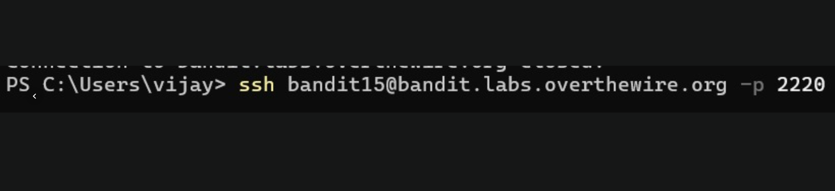
Then connect to the SSL service:
openssl s_client -connect localhost:30001
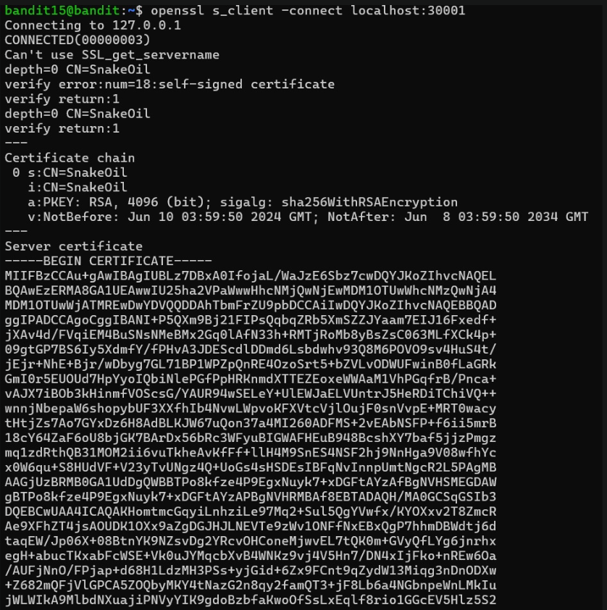
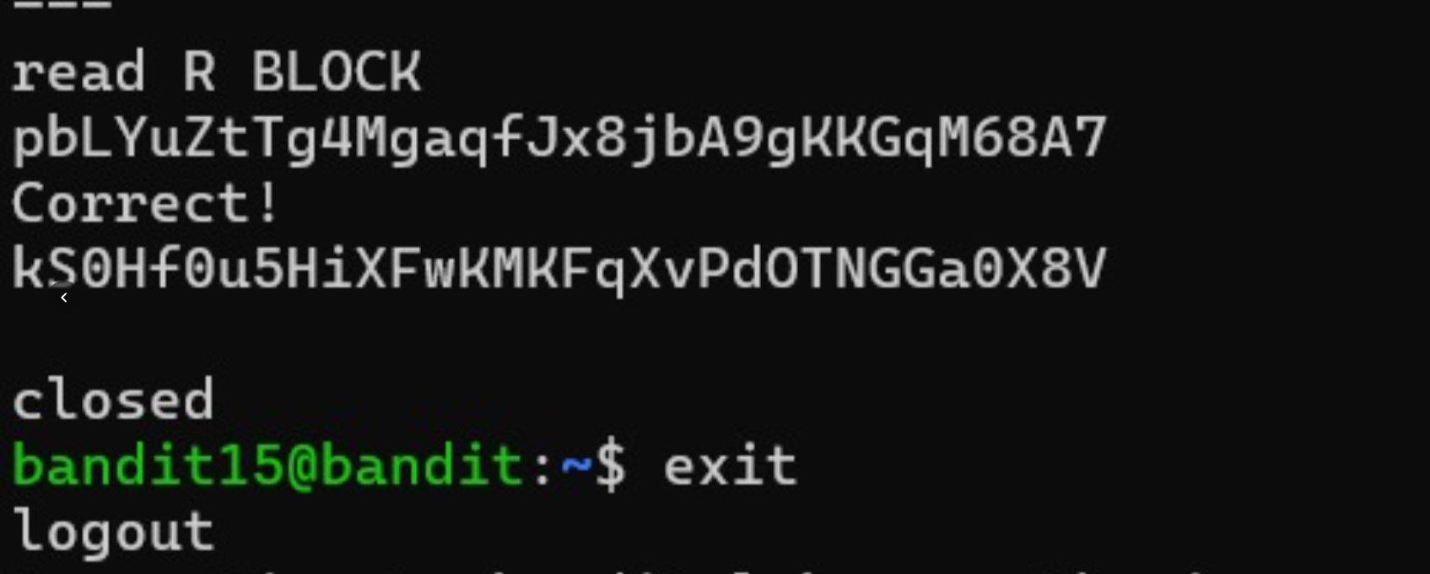
The connection displays the server certificate information. After the connection is established, enter the Level 15 password: pbLYuZtTg4MaqfJx8ibA9qKKGqM68A7
The server responds:
Correct!
The password for the next level is:
kSOH8u5HiXFWKMKFqXvPdOTNGGa0X8v
then exit from the level

